
UNIVERSITY INSTITUTE OF COMPUTING
PROJECT REPORT
ON
CAR RENTAL MANAGEMENT SYSTEM
DBMS MINI PROJECT — MySQL
SUBJECT: DATABASE MANAGEMENT SYSTEM

SUBMITTED BY:
Name: Varun Parmar
UID: 25BCD10123
Branch: BCA Data Science
Group: B Section: 25BCD (2)
Semester: 3rd

SUBMITTED TO:
Name: Ms.Harkamal kaur
Designation: Assistant professor
Date of Submission: 28 October 2026
Signature:

Project Report: Car Rental Management System

1. Introduction
The Car Rental Management System is a database mini project designed to maintain records of customers, vehicles, and rental transactions in an organized way. A rental business needs to know which cars are available, who rented each car, the rental period, and the amount charged. Keeping these details in separate paper records can cause duplication, inconsistency, and difficulty in searching.
This project uses MySQL to store related information in three connected tables: customers, cars, and rentals. Primary keys uniquely identify records, foreign keys connect rentals to customers and cars, and constraints help protect data integrity. SQL queries are used to retrieve available vehicles, view rental details, calculate totals, and inspect query execution with EXPLAIN.
All names, contact details, vehicle registrations, and transactions in this report are fictional sample data.

2. Objectives / Problem Statement
Problem statement: Design a relational database that stores customer, vehicle, and rental information while reducing duplicate data and making common rental operations easy to query.
- Create a structured database for customers, cars, and rental transactions.
- Use primary keys and foreign keys to connect related records.
- Maintain vehicle availability and rental status.
- Retrieve rental records using JOIN queries.
- Use aggregate functions and GROUP BY to calculate customer-wise rental totals.
- Demonstrate subqueries, NOT EXISTS, CRUD operations, indexing, and EXPLAIN.
- Provide reproducible SQL code and sample outputs for academic evaluation.

3. Modules, Tools and Technologies Used
Module | Purpose
Customer Management | Stores customer name, phone, email, and driving-license number.
Car Management | Stores vehicle brand, model, registration number, daily rate, and availability.
Rental Management | Connects a customer with a car and records rental dates, amount, and status.
Reports and Queries | Displays available cars, rental details, totals, and rental-status counts.
Database Optimization | Demonstrates an index and uses EXPLAIN to inspect a query plan.

Tool / Technology | Use
MySQL 8.0+ | Relational database and SQL execution.
MySQL Workbench | Writing queries, running scripts, and capturing result-grid screenshots.
SQL | DDL, DML, joins, aggregates, subqueries, constraints, and indexing.
GitHub | Version control and sharing project files.

Database Tables and Relationships
customers (1) → (many) rentals; cars (1) → (many) rentals. Each rental refers to one customer and one car. A customer can have multiple rentals over time, and a car can appear in multiple rental records over time.
Table | Primary Key | Important Fields
customers | customer_id | full_name, phone, email, driving_license
cars | car_id | brand, model, registration_no, daily_rate, availability_status
rentals | rental_id | customer_id, car_id, rental_date, return_date, total_amount, rental_status

4. Code with Outputs
The complete executable MySQL script is supplied separately as car_rental_management.sql. It creates the database and tables, inserts sample records, and runs the demonstration queries. Execute the script in MySQL Workbench from top to bottom.

4.1 Database Creation and Table Structure
The script creates car_rental_db and the tables customers, cars, and rentals. It uses AUTO_INCREMENT primary keys, UNIQUE fields, foreign keys, a CHECK constraint for rental dates, and ENUM fields for status values.

4.2 Sample Output — Cars
car_id | brand | model | registration_no | daily_rate | availability_status
1 | Maruti Suzuki | Swift | CH01AB1234 | 1800.00 | Available
2 | Hyundai | i20 | CH01CD5678 | 2200.00 | Rented
3 | Honda | City | CH01EF9012 | 3000.00 | Available
4 | Tata | Nexon | CH01GH3456 | 2800.00 | Maintenance

This is an illustrative result table based on the sample INSERT statements. Capture the actual MySQL Workbench result grid for the hard-copy report.

4.3 Query: Rental Details with Customer and Car
Purpose: Demonstrates JOIN across the three related tables.
rental_id | customer | car | rental dates | amount | status
1 | Aman Sharma | Hyundai i20 | 10–12 Oct 2026 | 4400.00 | Completed
2 | Simran Kaur | Maruti Suzuki Swift | 22–24 Oct 2026 | 3600.00 | Ongoing
3 | Rohit Verma | Honda City | 25–27 Oct 2026 | 6000.00 | Booked

4.4 Query: Total Rental Amount by Customer
Customer | Total rental amount
Aman Sharma | 4400.00
Simran Kaur | 3600.00
Rohit Verma | 6000.00

The GROUP BY query combines rental records by customer and SUM() calculates the total amount for each customer.

4.5 Query: Rental Count by Status
Rental status | Number of rentals
Completed | 1
Ongoing | 1
Booked | 1

4.6 Other SQL Operations
- Available-car filter: uses WHERE availability_status = 'Available'.
- Subquery: finds rentals with an amount above the average rental amount.
- NOT EXISTS: identifies cars that do not appear in any rental record.
- CRUD demonstration: inserts a customer and updates a car's availability.
- Indexing: creates idx_rentals_status and runs EXPLAIN on a status filter.
GitHub Repository URL: ______________________________________________

5. Conclusion
The Car Rental Management System demonstrates how a relational database can organize customer, car, and rental information. The project applies table creation, data insertion, primary and foreign keys, constraints, JOIN queries, aggregate functions, subqueries, CRUD operations, and indexing. These features help retrieve information consistently and make the database easier to maintain. The current version is a classroom prototype using fictional sample data; a production system would also need authentication, role-based access, payment handling, stronger business rules, backups, and transaction management.

Appendix: Files Included
1. car_rental_management.sql — complete MySQL source code.
2. README.md — project description, run instructions, and suggested screenshots.
3. This report — formatted for printing and submission.

Faculty Evaluation Grid
Sr. No. | Parameter | Maximum Marks | Marks Obtained
1 | Project Title | 2
2 | Mini Project / Database Implementation | 5
3 | GitHub Upload Link | 1
4 | Output Screenshots | 1
5 | Following Prescribed Format | 1
 | TOTAL | 10

Appendix A — Complete MySQL Source Code
The following is the complete SQL script used for this project. Run it in MySQL Workbench or the MySQL command-line client. The sample output tables shown in Section 4 are illustrative; the screenshots requested by the assignment should be captured from actual execution.
-- CAR RENTAL MANAGEMENT SYSTEM
-- DBMS Mini Project | MySQL 8.0+
-- Educational sample data only
CREATE DATABASE IF NOT EXISTS car_rental_db;
USE car_rental_db;
DROP TABLE IF EXISTS rentals;
DROP TABLE IF EXISTS cars;
DROP TABLE IF EXISTS customers;
CREATE TABLE customers (
customer_id INT PRIMARY KEY AUTO_INCREMENT,
full_name VARCHAR(100) NOT NULL,
phone VARCHAR(15) NOT NULL UNIQUE,
email VARCHAR(100) UNIQUE,
driving_license VARCHAR(30) NOT NULL UNIQUE
);
CREATE TABLE cars (
car_id INT PRIMARY KEY AUTO_INCREMENT,
brand VARCHAR(50) NOT NULL,
model VARCHAR(50) NOT NULL,
registration_no VARCHAR(20) NOT NULL UNIQUE,
daily_rate DECIMAL(10,2) NOT NULL CHECK (daily_rate > 0),
availability_status ENUM('Available','Rented','Maintenance')
NOT NULL DEFAULT 'Available'
);
CREATE TABLE rentals (
rental_id INT PRIMARY KEY AUTO_INCREMENT,
customer_id INT NOT NULL,
car_id INT NOT NULL,
rental_date DATE NOT NULL,
return_date DATE NOT NULL,
actual_return_date DATE NULL,
total_amount DECIMAL(10,2) NOT NULL DEFAULT 0,
rental_status ENUM('Booked','Ongoing','Completed','Cancelled')

NOT NULL DEFAULT 'Booked',
CONSTRAINT fk_rental_customer FOREIGN KEY (customer_id)
REFERENCES customers(customer_id),
CONSTRAINT fk_rental_car FOREIGN KEY (car_id)
REFERENCES cars(car_id),
CONSTRAINT chk_rental_dates CHECK (return_date >= rental_date)
);
INSERT INTO customers (full_name, phone, email, driving_license) VALUES
('Aman Sharma','9876500001','aman@example.com','DL-CH-1001'),
('Simran Kaur','9876500002','simran@example.com','DL-CH-1002'),
('Rohit Verma','9876500003','rohit@example.com','DL-CH-1003');
INSERT INTO cars (brand, model, registration_no, daily_rate, availability_status) VALUES
('Maruti Suzuki','Swift','CH01AB1234',1800.00,'Available'),
('Hyundai','i20','CH01CD5678',2200.00,'Rented'),
('Honda','City','CH01EF9012',3000.00,'Available'),
('Tata','Nexon','CH01GH3456',2800.00,'Maintenance');
INSERT INTO rentals
(customer_id, car_id, rental_date, return_date, actual_return_date, total_amount, rental_status)
VALUES
(1,2,'2026-10-10','2026-10-12','2026-10-12',4400.00,'Completed'),
(2,1,'2026-10-22','2026-10-24',NULL,3600.00,'Ongoing'),
(3,3,'2026-10-25','2026-10-27',NULL,6000.00,'Booked');
-- QUERY 1: Display all cars
SELECT car_id, brand, model, registration_no, daily_rate, availability_status
FROM cars ORDER BY car_id;
-- QUERY 2: List cars currently available for rent
SELECT brand, model, daily_rate
FROM cars
WHERE availability_status = 'Available';
-- QUERY 3: Show rentals with customer and car details
SELECT r.rental_id, c.full_name,
CONCAT(ca.brand, ' ', ca.model) AS car,

r.rental_date, r.return_date, r.total_amount, r.rental_status
FROM rentals r
JOIN customers c ON r.customer_id = c.customer_id
JOIN cars ca ON r.car_id = ca.car_id
ORDER BY r.rental_id;
-- QUERY 4: Total rental amount by customer
SELECT c.full_name, SUM(r.total_amount) AS total_rental_amount
FROM customers c
JOIN rentals r ON c.customer_id = r.customer_id
GROUP BY c.customer_id, c.full_name
ORDER BY total_rental_amount DESC;
-- QUERY 5: Count rentals by status
SELECT rental_status, COUNT(*) AS number_of_rentals
FROM rentals
GROUP BY rental_status;
-- QUERY 6: Find rentals whose amount is above the average rental amount
SELECT rental_id, total_amount, rental_status
FROM rentals
WHERE total_amount > (SELECT AVG(total_amount) FROM rentals);
-- QUERY 7: Find cars that have never been rented
SELECT ca.car_id, ca.brand, ca.model
FROM cars ca
WHERE NOT EXISTS (
SELECT 1 FROM rentals r WHERE r.car_id = ca.car_id
);
-- QUERY 8: Add a new customer (example CRUD operation)
INSERT INTO customers (full_name, phone, email, driving_license)
VALUES ('Neha Gupta','9876500004','neha@example.com','DL-CH-1004');
-- QUERY 9: Update a car's availability after a return
UPDATE cars
SET availability_status = 'Available'
WHERE registration_no = 'CH01CD5678';

-- QUERY 10: Create an index and inspect query plan
CREATE INDEX idx_rentals_status ON rentals(rental_status);
EXPLAIN SELECT * FROM rentals WHERE rental_status = 'Completed';
-- Optional: verify final table contents
SELECT * FROM customers;
SELECT * FROM cars;
SELECT * FROM rentals;

Appendix B — Sample Query Outputs
These tables show the expected results for the supplied fictional sample records. They are text/table representations, not screenshots from a live MySQL session.

Output 1: Available Cars
brand | model | daily_rate
Maruti Suzuki | Swift | 1800.00
Honda | City | 3000.00

Output 2: Rental Details with Customer and Car
rental_id | customer | car | rental_date | return_date | total_amount | rental_status
1 | Aman Sharma | Hyundai i20 | 2026-10-10 | 2026-10-12 | 4400.00 | Completed
2 | Simran Kaur | Maruti Suzuki Swift | 2026-10-22 | 2026-10-24 | 3600.00 | Ongoing
3 | Rohit Verma | Honda City | 2026-10-25 | 2026-10-27 | 6000.00 | Booked

Output 3: Total Rental Amount by Customer
full_name | total_rental_amount
Rohit Verma | 6000.00
Aman Sharma | 4400.00
Simran Kaur | 3600.00

Output 4: Count Rentals by Status
rental_status | number_of_rentals
Booked | 1
Completed | 1
Ongoing | 1

Output 5: Above-Average Rental Amount
rental_id | total_amount | rental_status
3 | 6000.00 | Booked

Output 6: Cars Never Rented
car_id | brand | model
4 | Tata | Nexon

Output 7: EXPLAIN Query Plan
EXPLAIN returns optimizer-dependent columns such as id, select_type, table, type, possible_keys, key, rows, and Extra. Exact values depend on MySQL version and data statistics; capture the real EXPLAIN result from your own MySQL installation rather than copying a guessed plan.

Actual MySQL Output Screenshot
The following screenshot was provided after executing the SQL queries. It shows the customer, car, rental, joined rental details, customer-wise totals, and rental-status count outputs.
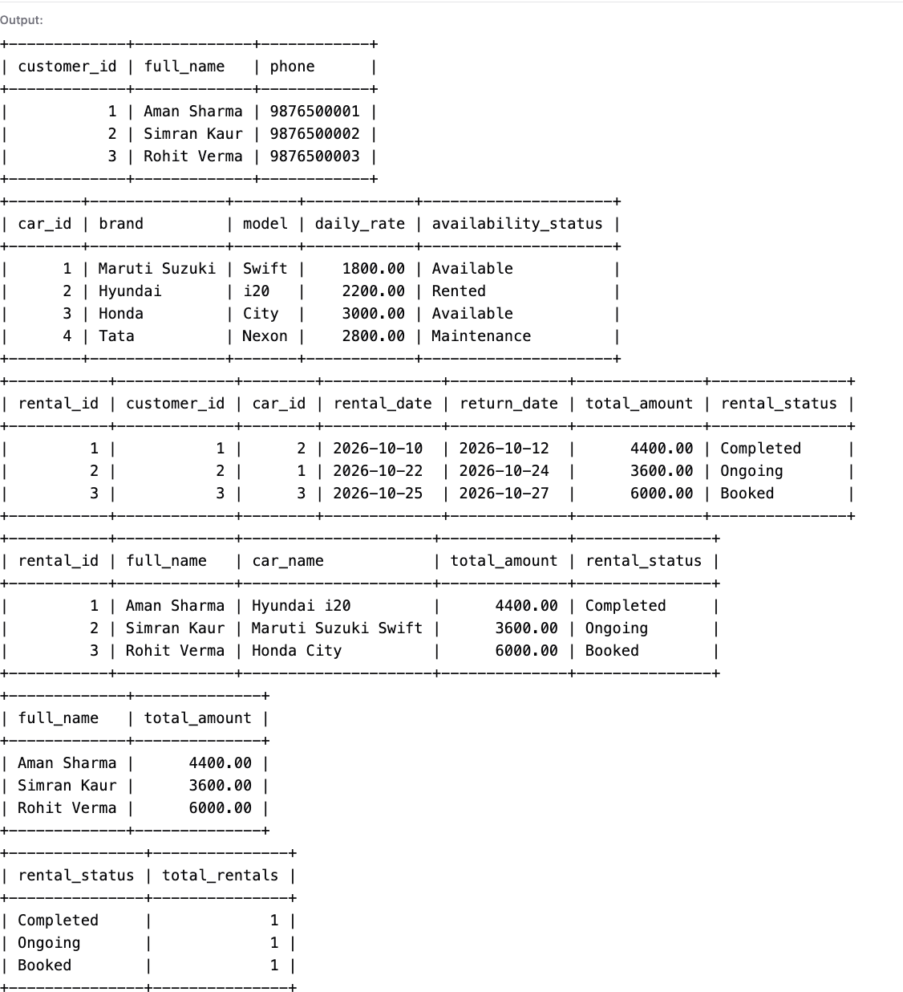
GitHub Repository URL:https://github.com/parmarvarun902-del/Car-Rental-Management-System-DBMS.git

